Thank you to our donors!
¡Gracias a nuestros patrocinadores!


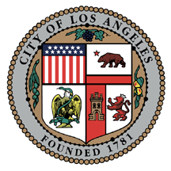

- Councilwoman Janice Hahn
City of Los Angeles, 15th District
- Shell Refinery
- Marcom Connections
- International Speed Print
- Trani’s
- Port of Los Angeles
- HealthNet
- The Latina Leadership Network
- The Beacon House Association
- Kids’ Plates
- ILWU

Flyer design by: Moi Cody

Thank you to our volunteers:
- Harbor College Service Learning
- Volunteer Center Youth Coalition
- Harbor College students from the following classes: Child Development, Math, Administration of Justice, Technology, Biology
- All of the participating agencies!

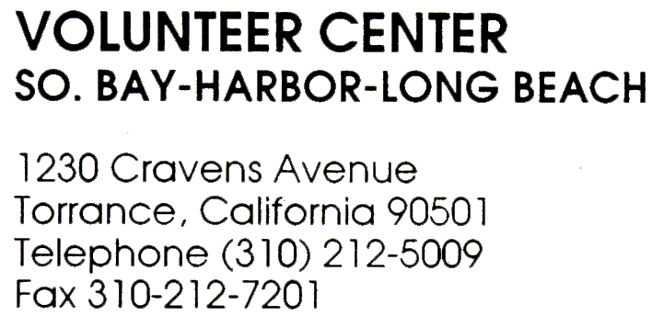

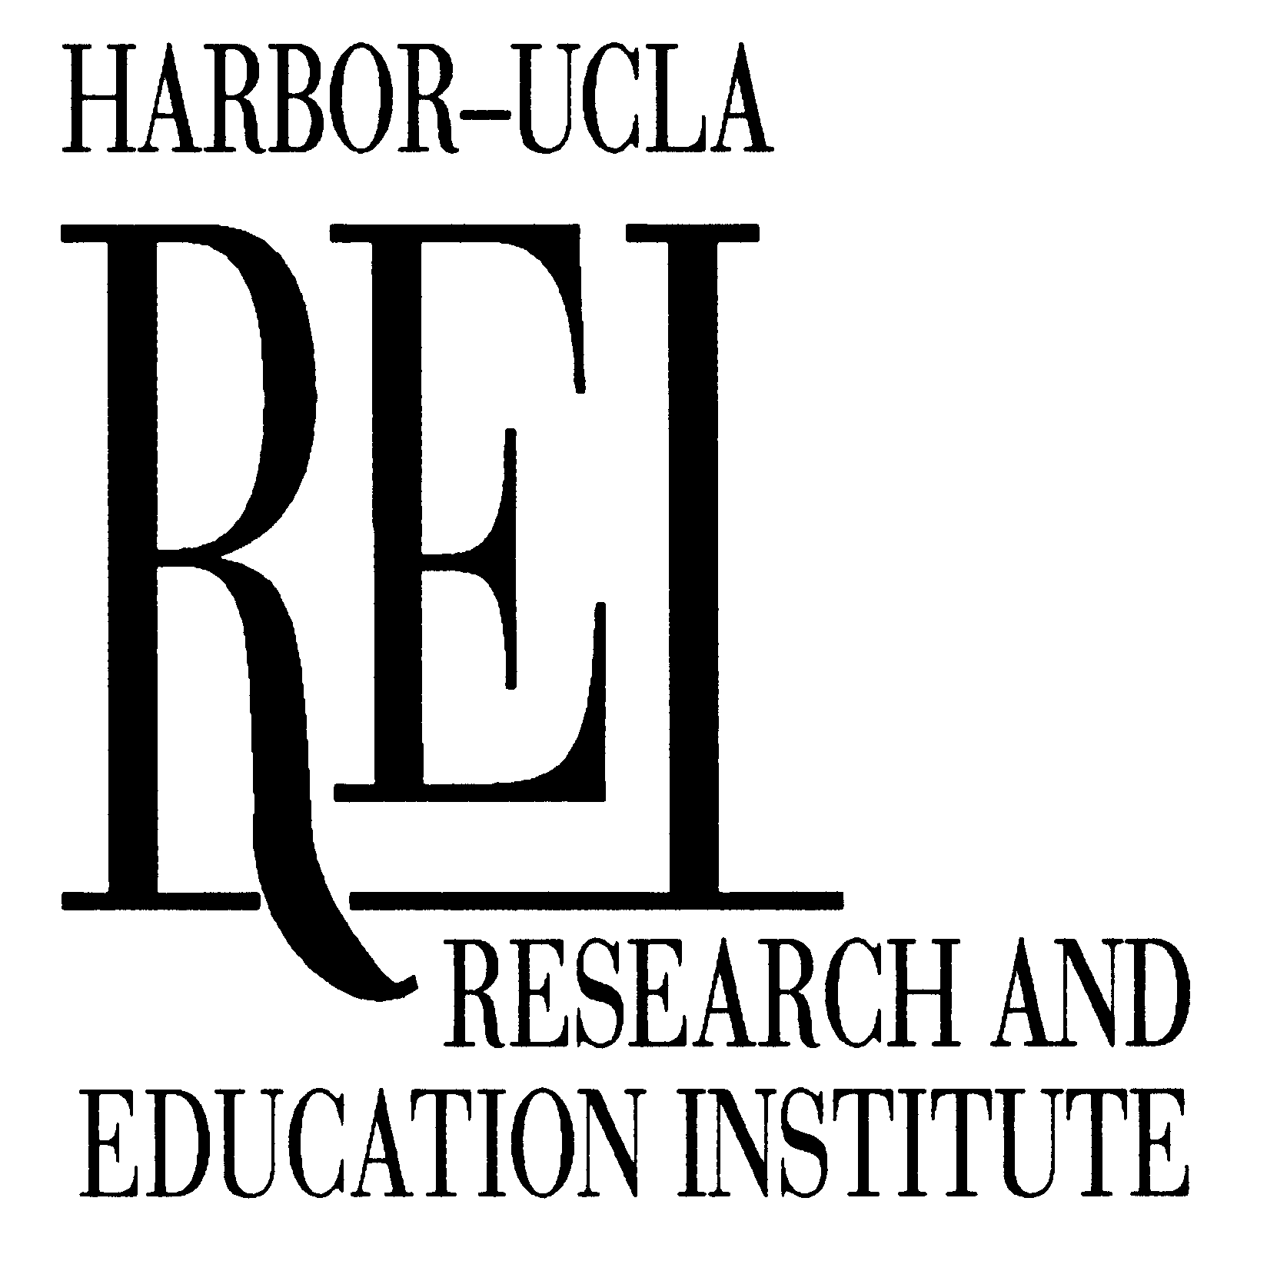

2nd Annual
Los Angeles Harbor
Child Safety Fair

Segundo Aniversario de la Feria de Seguridad de Los Niños de LA Harbor

At/En Los Angeles Harbor College

Sponsored by/Patrocinado por:
Research and Education Institute
October 26 2003
Halloween Safety Tips!
- Plan costumes that are bright and reflective.
- Make sure that shoes fit well.
- Consider adding reflective tape to costumes for greater visibility.
- Use makeup instead of a mask.
- Obtain flashlights with fresh batteries for all children and their escorts.
- Openly discuss appropriate and inappropriate behavior at Halloween time.
- Take extra effort to eliminate tripping hazards on your walkway.
- A parent or responsible adult should always accompany young children.
- Never cross between parked cars or mid-block.
- Always walk. Never run across a street.

¡Consejos de seguridad para Halloween!

- Use disfraces que sean brillante y reflectante.
- Asegurase que los zapatos sean del tamaño correcto.
- Considere usar cinta reflectante en los disfraces para tener más visibilidad.
- Use maquillaje en vez de una máscara.
- Obtenga una linterna con pilas nuevas para todos los niños y sus acompañantes.
- Hable sobre el comportamiento correcto al igual que el comportamiento inadecuado durante Halloween.
- Eliminen del camino objetos que puedan ocasionar que los niños tropiecen.
- Un padre u otro adulto responsable siempre debe acompañar a los niños.
- Nunca cruce por entre carros parqueados o en medio de la cuadra.
- Siempre camine. Nunca corra al cruzar la calle.

Participants/Participantes

American Youth Soccer Organization (AYSO)
Banning High School and Community Pool
Beacon House
California Highway Patrol
Children’s Hospital Los Angeles
Children’s Institute International
Entravision Radio Los Ángeles, Oye! 97.5 FM “La Cumbia Caliente”
Galaxy Shuttle
Harbor College Extension Program
Harbor Community Adult School, Meyler Adult Learning Center
Harbor Regional Center
Harbor-UCLA/REI Childhood Injury Prevention Center
Hawaiian Avenue Elementary School
Health Net
Home Depot
International Bird Rescue Rehabilitation Center
Los Angeles City Fire Department
Los Angeles County, Department of Health Services – Injury and Violence Prevention Program
Los Angeles Police Department, Harbor Division
- Fingerprinting for children/Huellas digitales para los niños
Los Angeles County Fire Department
- Earthquake Simulator/Simulador del terremoto
Preferred IPA
SafetyBeltSafe, U.S.A.
- Booster Seat Demonstration/Demostración de las sillas elevadas en el carro para niños
South Bay Literacy Council
Southern California Risk Watch® Coalition
The Volunteer Center (South Bay-Harbor-Long Beach)

Entertainment/Entretenimientos
- Harbor City Step Team, NFL/YET Boys’ and Girls’ Club of Harbor City.
- Xtreme Salsa Dance team, Los Angeles Harbor College Salsa Class.
- Storytelling for Children/Lectura de cuentos para niños, Reading done by/Presentado por Harbor College Child Development Class.
- Tae Kwon Do, LAPD Jeopardy

