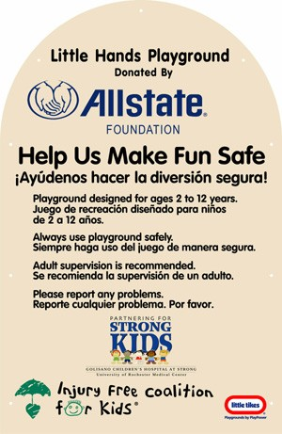
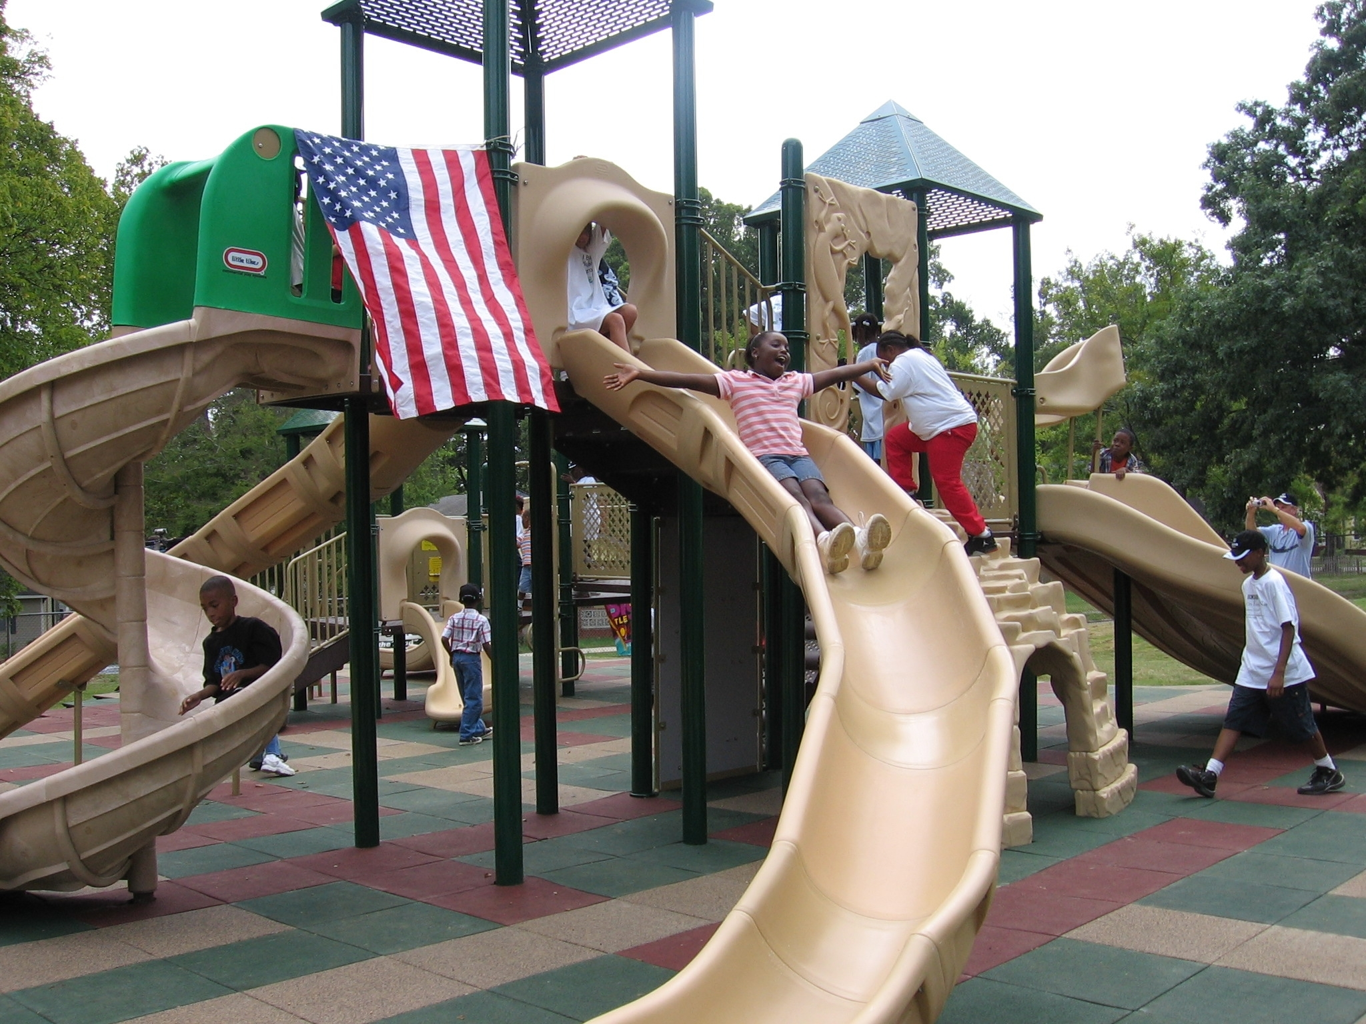
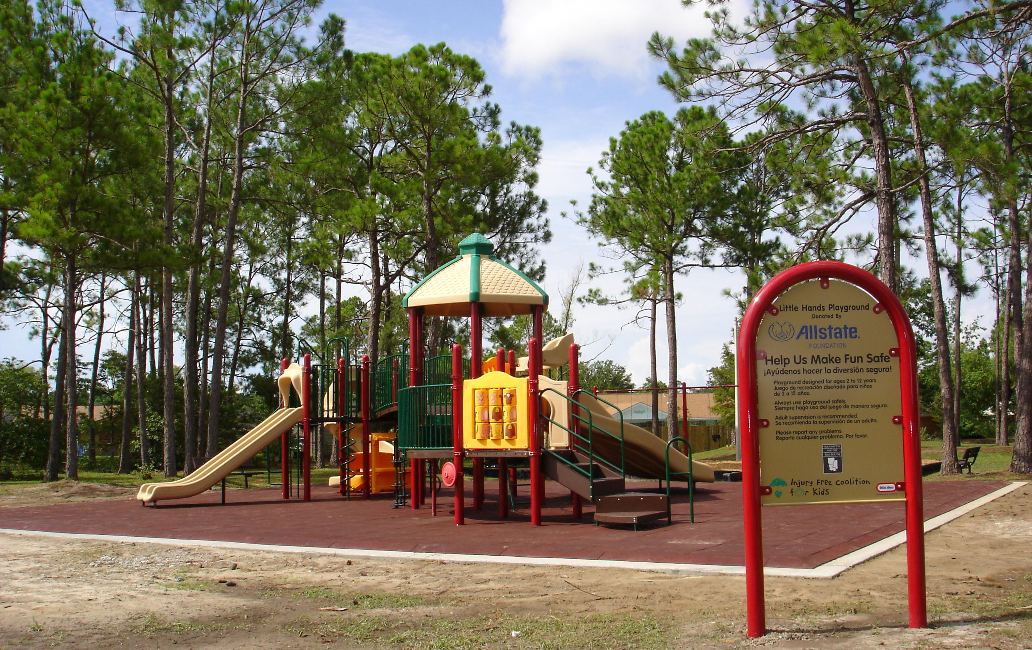

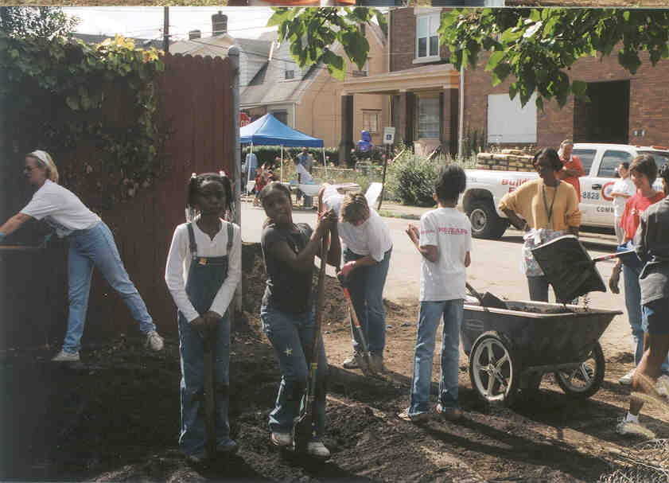

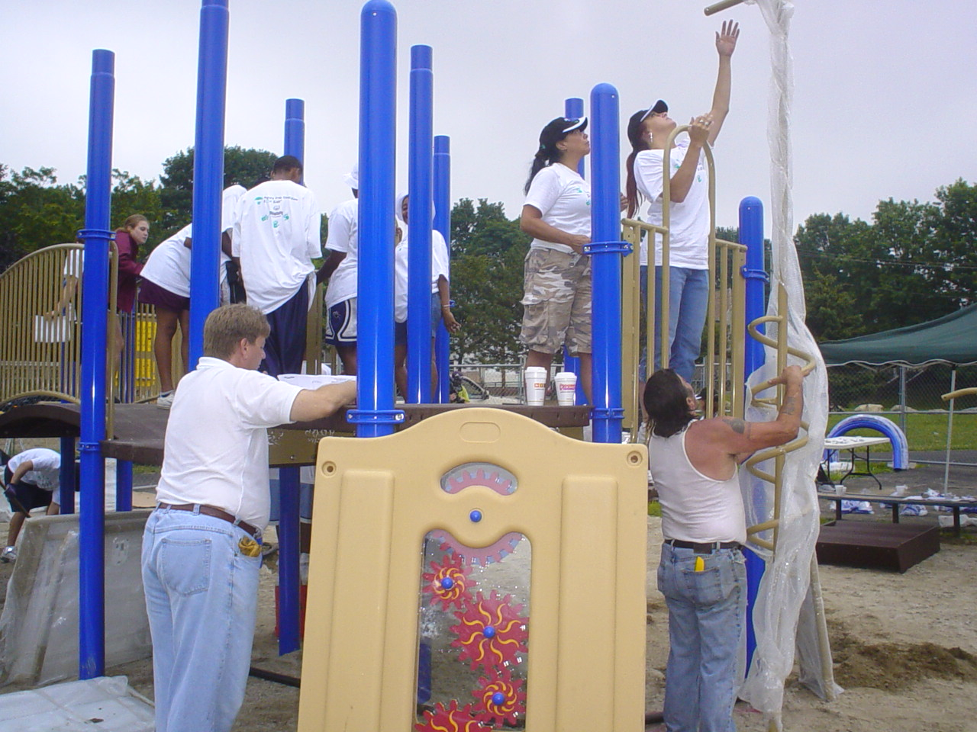
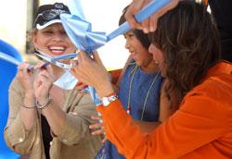

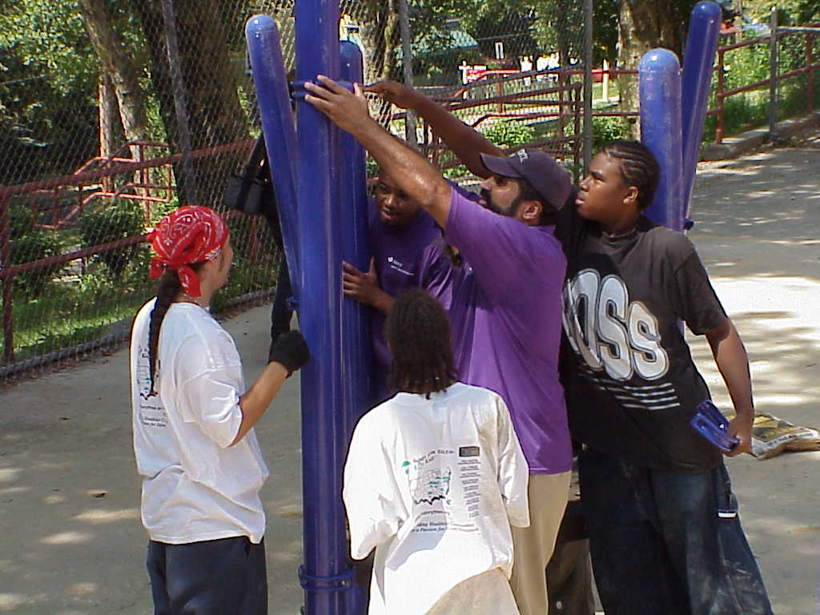

2007 Allstate Little Hands Playground Project
Request for Proposals
The Injury Free Coalition for Kids® (Injury Free) is located at the Columbia University, Mailman School of Public Health. Our driving force is a desire to reduce the number of children injured and killed in the United States where injuries are the number one cause of death and hospitalization of young people. Injury Free Coalition for Kids has proven that through research, education, community-based activities, and evaluation, each member site can make a difference in the community it serves. For example, by way of these efforts the Harlem Hospital Injury Prevention Program (HHIPP) in New York City reduced injury rates in Central Harlem by 60%.
It has been documented that urban children who are victims of pedestrian crashes have high level of exposures from a variety of circumstances related to their routine outdoor playground and street crossing activities. We have found that community interventions involving the creation of safe and accessible play areas are an important and effective method for preventing unintentional injuries to children. Designing and building safe play areas for urban children has been particularly effective in reducing pediatric pedestrian injury. For this reason, the Injury Free Coalition for Kids sites of Northern Manhattan have focused on playgrounds located in parks, public elementary schools and pre-schools. Over 70 playgrounds have been constructed in the area.
The partnership between The Allstate Foundation and Injury Free Coalition for Kids began in 2001 to encourage member sites to develop safe play areas in an effort to revitalize communities and empower their private citizens. The Allstate Little Hands Playground projects set out to involve a broad coalition of community members which serves to rebuild distressed communities and reestablish community spirit while providing safe places for the children to play. By way of The Allstate Foundation’s generous grants, Injury Free Coalition for Kids sites across the country have promoted safe and vital communities which emphasize tolerance, inclusion, diversity and economic empowerment through the Little Hands Safe Playground projects. There are currently twenty-six Allstate Little Hands Playgrounds across the country in the Injury Free cities of Atlanta, Austin, Birmingham, Chicago, Cincinnati, Detroit, Indianapolis, Kansas City, Lexington, Little Rock, Los Angeles, Miami, Peoria, Pittsburgh, Providence, Portland, Rochester, San Diego and St. Louis. Among these projects are two community built playground projects in the Gulf city of Biloxi, MS. On August 29, 2005, Biloxi was devastated by Hurricane Katrina. The playground projects have served as visible and tangible monuments on which the people of Biloxi can expand upon for long-lasting improvement.
For the 2007 calendar year, the Allstate Foundation has contributed funds to support five Allstate Little Hands community built playgrounds projects at Injury Free sites across the country. The Injury Free sites will compete for a $60,000 grant that will provide funding for the projects. The funds are to be used towards the cost of the playground equipment and related expenses including playground safety surface consisting primarily of rubber tiles or Pour & Play™. In addition to the $60,000 grant funding, the Regional Allstate Representative will provide a total of $10,000 to cover the cost of playground maintenance and community safety events during the five years following the completion of the playground project.
This Request for Proposals is highly competitive. A site selection committee reviews each proposal and selects the sites that will enter a subcontract agreement with the Trustees of Columbia University in the City of New York and the Injury Free Coalition for Kids, National Program Office. The site selection committee consists of the following people: Jan Epstein, Director of the Allstate Foundation; Vanessa Martelli, Playground Project Coordinator, Universal Play Systems, Inc., and the Injury Free Coalition for Kids, National Program Office staff, Dr. Barbara Barlow, Executive Director; Sally Jacko, Deputy Director; E. Lenita Johnson, Communications & Marketing Director and DiLenny Roca-Dominguez, Administrator. Sites who have received funding from the Allstate Foundation for a Little Hands playground in the past are welcome to apply but first-time applicants will be given a preference. Grant proposals are due Friday February 2, 2007.
OVERVIEW:
To ensure the goals of the Little Hands Playground Projects are met, this Request for Proposals (RFP) requires intensive collaborations with many individuals, agencies and groups in your area. It is imperative that you meet all the requirements of the RFP in order for your proposal to be considered for review and selection process.

Step 1:
From the beginning of the planning process you must contact and partner with your Regional Allstate Foundation representative. You will work together to develop the proposal and budget in response to this RFP. A list of all Allstate Regional Representatives is provided. A letter of support from the Allstate Regional Representative is required, proposals without this letter of support will not be considered for review. A template of the letter of support can be found in the appendix section of this Request for Proposals.

Step 2:
Little Tikes Commercial Playgrounds (aka PlayPower LT Farmington) provides the highest quality and safest playground equipment available. For that reason, Little Tikes and their local representatives have become sole source vendors of all Injury Free Coalition for Kids playgrounds and the Allstate Little Hands Playground Projects. They provide high standards of equipment and service, discounted equipment, insurance with indemnification for all programs and last, but not least, are adept at managing community-built playgrounds. Contact Vanessa Martelli who will recommend a local Little Tikes playground equipment representative in your area who is a qualified playground designer and holds a current certificate in playground inspection (CPSI) from the National Recreation and Park Association. The Little Tikes playground equipment representative will work with you to design a playground which incorporates the variable elements that the community coalition desires while observing all the safety standards. He/she will also provide you with the required playground design items to be included with the proposal (See PLAYGROUND DESIGN SECTION) and will coordinate the construction of your community built project, if funded.

Step 3:
For liability reasons, projects on private land may not be funded.

- Identify a site on public land, such as a public school or public park. The playground designer will be able to provide assistance in evaluating a site, addressing issues such as drainage, grading, lighting, traffic, sub-grade conditions and accessibility.

- Obtain approval, in the form of a Letter of Support, to build a playground on the identified site from all persons responsible for the site (e.g. Board of Education, School Facilities, Department of Parks and Recreation, owner/manager of the property). The letter of support is required. On the letter, the person(s) responsible for the site agrees to proceed with the project, agrees to include the uniform recognition signage and agrees to complete the playground by the end of the 2007 calendar year, should it be funded.

Note:
1. When working in a public space such as a park or school, you must also contact the owner/manager of the property under review. Many times a municipal agency will have stipulations that dictate where a playground can be installed.

2. A major priority is to bring all parties involved together to discuss a site in advance of any playground plans.

PROPOSAL:
Using a maximum of three pages, please provide the information requested below.
Note: The page limit extends to the proposal only and does not include the required attachments.

- Describe the physical site you identify. Explain how and why you chose the particular site.

- Demonstrate the need for a safe playground in the community of choice using data from the injury surveillance system. Describe the injury types and rates. Provide information regarding the population density and demographics of the community served. You may include charts and graphs to illustrate the data as attachments. Also, indicate the proximity of other play spaces in the area and describe their condition (attach a map illustrating the proximity of other play spaces to the site of choice.) Substantiate the need for a safe playground at the particular site chosen with photographs that show the site and a site evaluation survey to point out any apparent hazards.

- Identify the community partners you plan to work with and describe how you will work together to complete the community built playground project.

- Describe the other sources of funding from which you will obtain the difference between the $60,000.00 of this award and the total cost figure in your playground budget. Include a line item budget that indicates all sources of funding.

- Identify the individual in the department at your institution (e.g. marketing, public relations, or communications) who will work with your site, the National Program Office staff and The Allstate Foundation staff to develop and implement the media launch event that will accompany the playground build and dedication.

PLAYGROUND DESIGN: The Little Tikes playground designer will provide you with the following items to be submitted with the proposal:

- 2-D rendering of playground equipment
- 2-D rendering of safety surface
- 3-D color rendering of proposed playground equipment that shows placement of the uniform recognition signage
- A written site evaluation/survey addressing issues such as drainage, grading, lighting, traffic, sub-grade conditions and accessibility
- A list including product literature of any additional playground site amenities (e.g. benches, trash containers, murals, etc.)
- Complete and detailed budget for the project
- Resume of previous playgrounds built at your site (if applicable)

UNIVERSAL SIGNAGE: All playgrounds funded through this Request for Proposals must include the uniform recognition signage. A representation of the sign is attached. This signage will provide recognition to the Allstate Foundation and other funders of the playground. It will also include multilingual playground safety information. Vanessa Martelli can provide you with specifics regarding the uniform recognition signage.
CHECKLIST

- COVER PAGE

- PROPOSAL (Includes proposal narrative, playground design, budget, budget narrative and other required attachments)

Narrative (Maximum of 3 pages)

- Public land site chosen:

- Description of the physical site identified

- Identify community partners involved

- Need proven with data from injury surveillance system. Describe the following:
- Injury types
- Injury rates
- Population density of community served
- Demographics of community served
- Proximity and condition of other play spaces

- Identify sources of funding for the playground project

- Individual identified to assist with media launch event

Playground Design

- Playground designer:

- Design includes:

    - 2-D rendering of playground equipment
    - 2-D rendering of safety surface
    - 3-D color rendering of proposed playground equipment that shows placement of the uniform recognition signage

- A written site evaluation/survey addressing issues such as drainage, grading, lighting, traffic, sub-grade conditions and accessibility

- A list including product literature of any additional playground site amenities (e.g. benches, trash containers, murals, etc.)

- Complete and detailed budget for the project

- Resume of previous playgrounds built at your site (if applicable)
2007 Allstate Safe Playgrounds, Request for Proposals (RFP)
Checklist Continues

- Budget and Budget Narrative

- Required Attachments

- Letter of support from your Regional Allstate Foundation representative

- Letter of agreement from hospital administrator and entity with which Columbia University will subcontract for funds if awarded

- Letter of agreement from the responsible person(s) at the chosen site

- A directory with the contact information of the people responsible for the chosen site (e.g Directory of the Parks and Recreation Department, Directory of Office of School Facilities and the name and contact information for the Principal of the school)

- Photographs of the site to substantiate the need for a playground

- Map(s) indicating site and the proximity of other play spaces

- You may include charts and graphs to illustrate the data as attachments

- Deadline:
Send two originals and 4 copies for delivery on or before Friday February 2, 2007 to the Injury Free Coalition for Kids, National Program Office, C/O DiLenny Roca-Dominguez.

Template - Letter of Support
Regional Allstate Foundation

<Regional Allstate Foundation Letterhead>

Barbara Barlow, MD
Columbia University/ School of Public Health
722 W. 168th Street, Room 1709
New York, NY 10032

Dear Dr. Barlow,

I, <Name of Rep>, the Regional Allstate Foundation representative for <City, State> am committed to the development of safe play spaces as an effective tool in injury prevention and community revitalization.

I agree to work with the staff of Injury Free Coalition for Kids of <City> at <Hospital> in the entire process of a community-built playground, funded in part by The Allstate Foundation in partnership with the Injury Free Coalition for Kids National Program Office.

This process includes:

- Site selection
- Playground design development
- Community build
- Media launch event
- Playground dedication ceremony
- Any media activities associated with the playground

I understand that strong community relationships are the key to maintaining a safe play area and through events such as health fairs or car seat checks that can be held at or near the playground we can empower the community to make a difference in their lives and their neighborhood. For this reason, I pledge to provide $10,000 to aid in the annual maintenance of the playground and to support the community relationships that will be formed with the inception of this project. This $10,000.00 grant covers a 5-year period and will be provided in one $10,000 grant or two $5,000 grants (chose one) to ____name of agency the check will be made out to i.e. the hospital, the university, the park, the school___.

Sincerely,

<Name of Rep>, <Title>
DiLenny Roca-Dominguez  Administrator  Injury Free Coalition for Kids, NPO  Columbia University  School of Public Health  722 West 168th Street, Room 1709  New York, NY 10032  Tel (212) 342-0514  Fax (212)342-0519  dr146@columbia.edu | DiLenny Roca-Dominguez serves as the Allstate Little Hands Playgrounds Grant Administrator. She provides technical assistance throughout the grant process and serves as the main contact person once the sites are selected for funding relating to all aspect of the subcontracting process between the Trustees of Columbia University in the City of New York and the selected sites including setting up the subcontracts, disbursement of funds and closing of the project. All sites will keep the NPO and The Allstate Foundation informed of build dates, dedication dates and any problems or strides experienced throughout the project.
DiLenny Roca-Dominguez, Allstate Little Hands Playgrounds Grant Administrator

E. Lenita Johnson, Allstate Little Hands Playgrounds Communications Coordinator
E. Lenita Johnson  Communications Director  Injury Free Coalition for Kids  Columbia University  School of Public Health  2639 Charlotte  Kansas City, MO 64108  Tel (816) 651-7777  Fax (816)421-0817  estelljohnson@msn.com | E. Lenita Johnson serves as the National Marketing Director for the Injury Free Coalition for Kids, and assists with coordinating the Communications efforts between sites, their hospitals and communities, Allstate and other sponsors, if they exist. It is important to contact her early in the planning process so that media efforts can be coordinated for both the build and the dedication. Releases reflecting the purpose of the project and everyone’s role must be developed. Ms. Johnson will be able to provide samples of past releases. Little Hands brochures, fliers, hats and t-shirts will be available for distribution to the community where the playgrounds are being built. Sometimes efforts to coordinate who will play what role in the communications process can be difficult; therefore, it is important that Lenita be contacted early in the planning process.

Vanessa Martelli, Project Coordinator
Vanessa Martelli  Project Coordinator  Universal Play Systems, Inc.  83 Lincoln Avenue  Pelham, NY 10803  Tel (914) 576-0666 *16  Fax (914) 576-0238  Vmmartelli@universalplay.com | Vanessa Martelli represents Universal Play Systems, Inc., the sole distributor for Little Tikes equipment in the state of New York. Vanessa Martelli is the Project Coordinator for playground projects constructed in New York City. Since 1992 she has served as the playground designer and coordinator for the Harlem Hospital Injury Prevention Program and now designs, constructs and conducts safety inspections for Injury Free Coalition for Kids. She will provide you with contact information for a Little Tikes playground designer in your area. Vanessa can answer questions regarding the playground design, playground surfacing and will provide you with specifics regarding the uniform recognition signage

These are words of wisdom from Vanessa Martelli:

Once the need for a playground in a community and a potential location has been established, it is time to call in a playground designer. A playground designer is someone that holds a current certificate in playground inspection from the National Recreation and Park Association. They should have at least 5 years experience in the playground industry and represents a major playground product line. This person should be able to provide you and the community with color catalogs, layout drawings, 3D renderings for public relations and a written site evaluation for your use in community relations. The designer that you work with will also be the person that coordinates the actual construction end of your community built project. A playground designer that works with a major manufacturer should never charge your organization any fees for their services, only products.

Within most communities there are bound to be numerous areas appropriate for a good playground build. It is imperative that you do your initial search evaluations with your trained playground designer. The designer will be able to provide assistance in evaluating a site, addressing issues such as drainage, grading, lighting, traffic, sub-grade conditions and accessibility. When working in a public space such as a park or school, you must also contact the owner/manager of the property under review. Many times a municipal agency will have stipulations that dictate where a playground can be installed. Make it a priority to bring all parties involved together to discuss a site in advance of any playground plans. Food for thought - look for areas that tend to be level, well lit, accessible by walking, and ground level. Keep your eyes open for danger signs; rooftop areas, dark corner lots, and areas with numerous underground utility lines.

If you find that you have been presented with a site and your playground designer feels that it is not appropriate for a playground, do not feel discouraged. New installation techniques and playground applications are being developed daily. There is always a way to make it work if you do your homework and communicate your needs! A word of caution though, occasionally additional professionals will have to be brought in to the project such as engineers (both mechanical and structural), landscape architects, welders and landscape contractors. Occasionally we must pay for their services to ensure a successful project.

The letter of support stipulates that the Allstate Regional Representative agrees to provide $10,000 to aid in five years of annual maintenance of the playground and to support the community relationships that will be formed with the inception of this project. In addition, the Allstate representative also agrees to work with the Injury Free Coalition for Kids staff throughout the process which includes: site selection, playground design development, community build, media launch event, community leader outreach, playground dedication ceremony, and any media activities associated with the playground.

Exposure to Traffic Among Children Injured as Pedestrians, JC Posner, E Liao, FK Winston, A Cnaan, K N Shaw, DR Durbin, Injury Prevention 2002, 8:231-235

