(Community Organization and/or Business Name)
(Address)
Dear______, (Date)

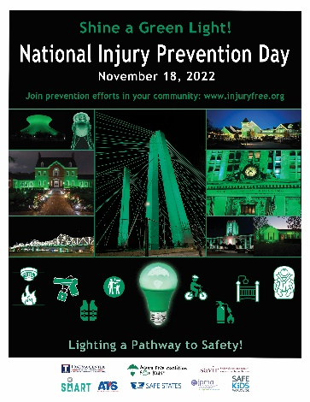
Did you know that injuries and violence are the number one killers of people 1 to 44 years old? Your Organization (Injury Free Pittsburgh, Safe States, Safe Kids World Wide…), is working to address the needless injuries and violence taking place in Your catchment or service area. Their deaths make up more deaths than all other diseases combined. Please help make a difference. “Shine a Green Light” on November 18th, 2021, National Injury Prevention Day, to help raise awareness about the need for change.
Across the country, some of the nation’s leading injury and violence prevention organizations will come together to work for change. They will join forces to push for change on the 2nd annual "National Injury Prevention Day." It is our hope that you will take part. By stepping up you will be joining Injury Free Coalition for Kids®, Safe Kids Worldwide, Safe States Alliance, the American Trauma Society, the American Academy of Pediatrics, BeSMART a division of Everytown for Gun Safety, the Society for Advancement of Violence and Injury Research, the Trauma Centers of America Association and JPMA Cares a division of the Juvenile Products and Manufacturers Association. Learn more by going to: https://injuryfree.org/nationalinjurypreventionday/2022 scroll down to see this year’s events. If you are interested in hosting an event for National Injury Prevention Day, contact estelljohnson@sbcglobal.net with any questions. You can list your own NIPD events by submitting them at https://injuryfree.org/admin/nipdprogram_edit.cfm.

We ask you to do what you can in this nationwide effort. Make sure buildings and city landmarks shine green lights, take part in Injury Prevention events in your community, and join the Twitter chat with @InjuryFreeKids using the hashtag #BeInjuryFree at 1:00 pm EST on November 18th.
In addition to raising awareness to prevent injuries and acts of violence, communities across the country will be empowered with knowledge about safety practices, products, and policies. Our children, our young people and their families deserve to be live injury free. Step up and be a part of the change to make that happen.

Sincerely,

Your Signature
You Title
Your Organization

